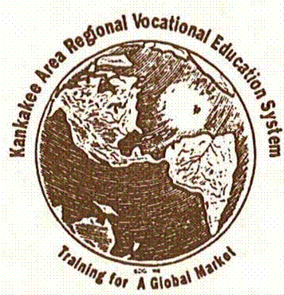

November 10, 2016

To: Members of the KACC/KARVES Executive Committee and Administrative Board of Control

Grant Park –John Palan, KACC Executive Board Chairman
Beecher –Jeffrey McCartney & Larry Herman
Bradley – Scott Wakeley & Thomas Cooke (KARVES Administrative Board Chairman)
Central – Tonya Evans, Executive Board Secretary & Troy Meier
Herscher –Richard Decman Executive Board Vice-Chairman, & David Ruder
Kankakee – Genevra Walters & Karen Johnston-Gentry
Manteno – Lisa Harrod & Matthew Jackson
Momence – Gary Miller & Sandra Illum
Peotone –Steve Stein & Richard Uthe
St. Anne –Charles Stegall & Kurt Moranz
Regional Superintendent– Gregg Murphy

The regular monthly meeting of the KACC Executive Committee and quarterly meeting of the KARVES Administrative Board of Control will be held concurrently at 6:00 p.m. on Thursday, November 10, 2016 at Kankakee Country Club, Kankakee, Illinois. Please contact us if you will be unable to attend the meeting and if possible, provide an alternate representative to ensure a quorum.

Roll call

Public Comments
Consent Agenda (Items may be removed for discussion.)
- Approval of minutes from October Regular meeting of the Kankakee Area Career Center
- Approval of Minutes from the August KARVES/KACC Combined Regular Meeting Minutes
- Approval of Accounts Payable
- Approval of Financial Reports
Guest Presentation
- Elite Flight Training and Aircraft Management LLC
Director’s Comments
- Director’s Report
Discussion / Action Items
- Tuition Rates – Member/Non-Member Schools
- Director’s Position Update
Information Items
- Principal’s Report
- Special Populations/Assistant Principal Report
Closed Session
To consider information regarding Employment, and Contract Negotiations, collective negotiating matters between KACC and its employees or their representatives, or deliberations concerning salary schedules for one or more classes of employees, [5 ILCS 120/2(c)(2)].
Re-open Session
Other Business/General Comments
Adjourn

